**ID: DCW-1**

**Date Written –** 4/01/2020

**Date Revised –** 4/05/2020

**Author: Malia Rohrig, Ean Petersen, Erika Tiemeier, Jonathon Platt**

**Improvement on Existing Design**

The improvement on the current design involves the elimination of two bearings connected to the bearing hub. This modification will reduce mechanical deformation of the tubing due to a reduction in the amount of pressure points present. This change in the design will allow for velocity and flow rate to remain constant. Our design also includes a modification to the 3D printed housing to include a guard on both the bottom and the top of where the tubing is inserted. These guards are to ensure that the tubing will stay in place during the operation of the pump.

**User Needs**

*User Needs Matrix*

|  |  |
| --- | --- |
| User Need ID | Description |
| UN-1 | Improved UX / UI to allow for operator control. |
| UN-2 | Improve Solidworks files to include assembly, hardware, configurations, and drawings. |
| UN-3 | Eliminate warping of the printhead resulting from heat generated from the motor. |
| UN-4 | A method to stop or detach pump heads individually when part of a multi-pump design. |
| UN-5 | Eliminate breadboard or prototype parts in circuit. |

**Design Inputs**

*Requirements Matrix*

|  |  |
| --- | --- |
| Design Input ID | Requirement |
| DI-1 | User(s) can set pump flow rate up to 300 ml/min. |
| DI-2 | All parts shall be adept to optimize for one way fluid flow. |
| DI-3 | Printhead shall have a temperature resistant above 37C. |
| DI-4 | Users shall have the ability to adjust the number of pumps being utilized. |
| DI-5 | Circuit components shall be connected together in a single part. |

**Design Outputs**

*Technical Description:*

The revised pump will have at most two crimping/pressure points instead of three, as well as a guard on the top of the tubing and on the bottom to ensure that the tubing stays in place while the pump is running. The pump will also feature a new position for the attachment point of the inner part for quicker tube changes.

*Rendering(s):*

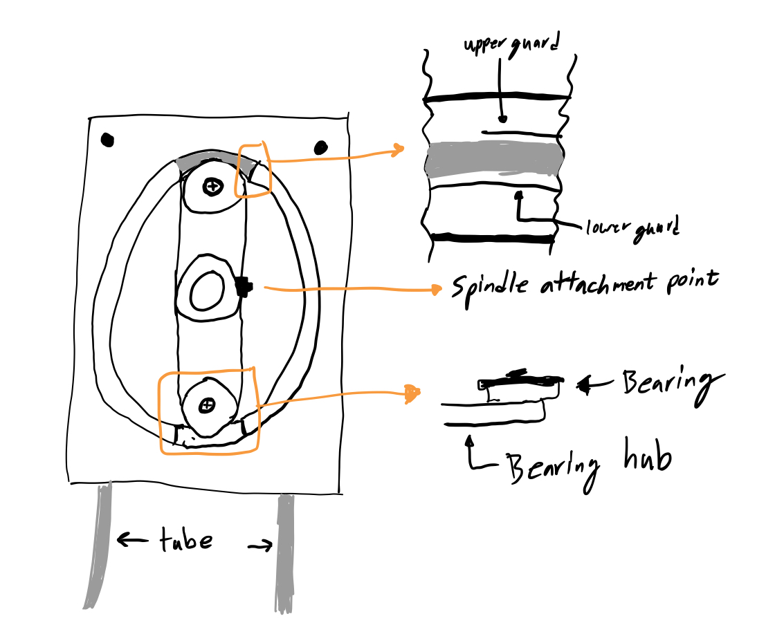

**Figure 1.** Revised micropump with modifications. 3D printed housing contains upper and lower guard to secure tubing (upper right), 3D printed bearing hub contains two bearings instead of four.

*Design Outputs Matrix*

|  |  |  |
| --- | --- | --- |
| Design Output ID | Design/Part | Data File Location |
| DO-1 | GUI Input elements programed in Arduino IDE | *C:\\Micropump\Arduino\UI Code* |
| DO-2 | Reduced Bearing Hub | *C:\\Micropump\STL Files\Bearing Hub* |
| DO-3 | Printhead was printed using silica-filled ceramic resin | *https://archive-media.formlabs.com/upload/Technical_Data_Sheet_EN_-_Ceramic.pdf* |
| DO-4 | 1/8” OD 1/16” ID tubing | *https://www.verderflex.com/en/product-support/technical-datasheet-download/* |

**Design Verification**

*Design Verification Matrix*

|  |  |  |  |  |
| --- | --- | --- | --- | --- |
| Design Verification ID | Description | Expected Value | Measured Value | Pass/Fail |
| DVE-1 | Pump maintains a sustained flow rate of 300 mL/min for a 5 min period | 300 mL/min | 300 mL/min | P |
| DVE-2 | No observable fluid backflow while operating at 300 mL/min | <10 mL/min | 2 mL/min | P |
| DVE-3 | Measured printhead heights at each corner with no major overall difference | < 0.05% difference overall | 0.02 % difference overall | P |
| DVE-4 | Can support up to 5 pumps without change to flow rate or functionality | 0<Pumps<5 | 4 pumps | P |

**Design Validation**

*Design Validation Matrix*

|  |  |  |
| --- | --- | --- |
| Design Validation ID | User Need ID | Description |
| DV-1 | UN-1 | Measures flow rate |
| DV-2 | UN-1 | Inputting different flow rates into the UI and measure change in outflow |
| DV-3 | UN-3 | Determines flatness after 37C environment |
| DV-4 | UN-4 | Activation of a varying number of pumps |
| DV-5 | UN-4; UN-5 | Verifies part attachment sites |